**0.Flowchart Symbols and their usage**

This is an overview. of all the flowchart symbols that you will use when drawing flowcharts and process flow. All these objects are available in Creately and you can try out a [demo](http://creately.com/creately-start/app?tempid=genwi2wl2) or take a look at some [sample flowcharts](http://creately.com/diagram-type/flowcharts) for more context.

[Terminal / Terminator](https://creately.com/diagram-type/objects/flowchart/terminal-terminator-flowchart-object)

https://creately.com/sites/default/files/objectdetail/thumbnails/start_end.png

The terminator is used to show where your flow begins or ends. Ideally, you would use words like 'Start', 'Begin', 'End' inside the terminator object to make things more obvious.

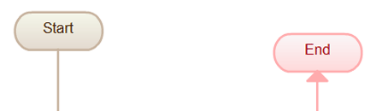

[Process / Rectangle](https://creately.com/diagram-type/objects/flowchart/process-flowchart-object)

https://creately.com/sites/default/files/objectdetail/thumbnails/process_0.png

Flowchart Process object is used to illustrate a process, action or an operation. These are represented by rectangles; and the text in the rectangle mostly includes a verb. Examples include 'Edit video', 'Try Again', 'Choose your Plan'.

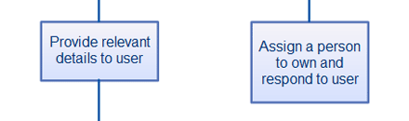

[Data (I/O)](https://creately.com/diagram-type/objects/flowchart/data-flowchart-object)

https://creately.com/sites/default/files/objectdetail/thumbnails/data.png

The Data object, often referred to as the I/O Shape shows the Inputs to and Outputs from a process. This takes the shape of a parallelogram.

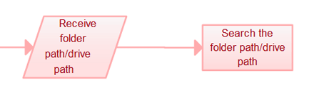

[Decision / Conditional](https://creately.com/diagram-type/objects/flowchart/decision-conditional-flowchart-object)

https://creately.com/sites/default/files/objectdetail/thumbnails/decision.png

Decision object is represented as a Diamond. This object is always used in a process flow to as a question. And, the answer to the question determines the arrows coming out of the Diamond. This shape is quite unique with two arrows coming out of it. One from the bottom point corresponding to Yes or True and one from either the right/left point corresponding to No or False. The arrows should be always labelled to avoid confusion in the process flow.

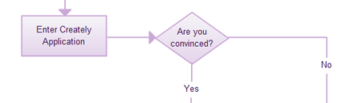

[Document](https://creately.com/diagram-type/objects/flowchart/document-flowchart-object)

https://creately.com/sites/default/files/objectdetail/thumbnails/document.png

Document object is a rectangle with a wave-like base. This shape is used to represent a Document or Report in a process flow.

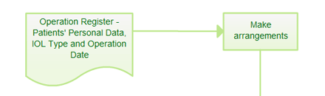

[Stored Data](https://creately.com/diagram-type/objects/flowchart/stored-data-flowchart-object)

https://creately.com/sites/default/files/objectdetail/thumbnails/storedData.png

This is a general data storage object used in the process flow as opposed to data which could be also stored on a hard drive, magnetic tape, memory card, of any other storage device.

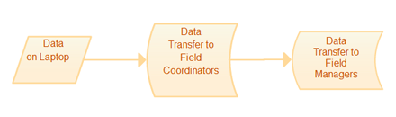

[Direct Data](https://creately.com/diagram-type/objects/flowchart/direct-data-flowchart-object)

https://creately.com/sites/default/files/objectdetail/thumbnails/directData.png

Direct Data object in a process flow represents information stored which can be accessed directly. This object represents a computer's hard drive.

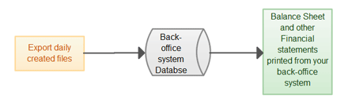

[Internal Storage](https://creately.com/diagram-type/objects/flowchart/internal-storage-flowchart-object)

https://creately.com/sites/default/files/objectdetail/thumbnails/internalStorage.png

This is an object which is commonly found in programming flowcharts to illustrate the information stored in memory, as opposed to on a file. This shape is often referred to as the magnetic core memory of early computers; or the random access memory (RAM) as we call it today.

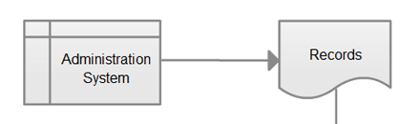

[Sequential Access](https://creately.com/diagram-type/objects/flowchart/sequential-access-flowchart-object)

https://creately.com/sites/default/files/objectdetail/thumbnails/sequentialAccessStorage.png

This object takes the shape of a reel of tape. It represents information stored in a sequence, such as data on a magnetic tape.

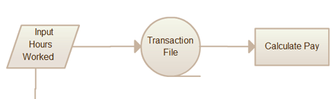

[Manual Input](https://creately.com/diagram-type/objects/flowchart/manual-input-flowchart-object)

https://creately.com/sites/default/files/objectdetail/thumbnails/manualInput.png

This object is represented by rectangle with the top sloping up from left to right. The Manual Input object signifies an action where the user is prompted for information that must be manually input into a system.

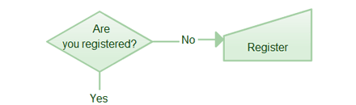

[Subroutine / Predefined Process](https://creately.com/diagram-type/objects/flowchart/subroutine-predefined-process-flowchart-object)

https://creately.com/sites/default/files/objectdetail/thumbnails/predefinedProcess.png

This shape takes two names - 'Subroutine' or 'Predefined Process'. Its called a subroutine if you use this object in flowcharting a software program. This allows you to write one subroutine and call it as often as you like from anywhere in the code.

The same object is also called a Predefined Process. This means the flowchart for the predefined process has to be already drawn, and you should reference the flowchart for more information.

